Ultimate Guillotine
https://www.myfantasyleague.com/2026/home/25918

Table of Contents
Rules
Scoring
Draft Grid
Weekly - Roster, Prize, Cut Schedule
Weekly Scores Example

Rules
- $50 entry (LeagueSafe https://www.leaguesafe.com/join/4410708)
- Guillotine (Chop) format - which means teams are eliminated through the year. 24 teams to start
  - As teams are eliminated, all of their players are returned to the free agent pool
- Roster
  - Starts at 8 players, no bench and starters are 1 QB, 2 RB, 2 WR, 1 TE, 2 FLX
  - Your practically are drafting your Week 1 lineup
  - As season progresses (if you survive), additional bench spots and starting spots will increase (see table below)
  - One injured reserve slot turned on after the draft (listed as IR or Out by MFL)
- Draft
  - Draft Date: Tuesday, September 1st at 9am ET
  - “Slow” draft at MFL. 30-minute draft timer. Timer off 11pm ET-9am ET.
  - 8 rounds. 192 picks total.
  - ~40 picks/day. Draft done in about a few (2-3) days.
  - Snake draft order. Draft order “slides” every odd round (see Draft Grid below)
  - Once all 24 teams paid, teams will be randomized to fit the draft grid. No refunds after draft order has been set.
- Transactions
  - Daily waivers (Wed to Sun, 11am ET). 1-day lock for dropped players
  - Waivers start the Wednesday (prior to the start) of NFL Week 1
    - This year - Wed., Sep 9th
  - $200 FAAB start
  - $0 min for waiver claims
  - First-come, First-served pickups cost $0 FAAB for unclaimed (unlocked) players. Occurs after waivers runs
  - No trades
  - 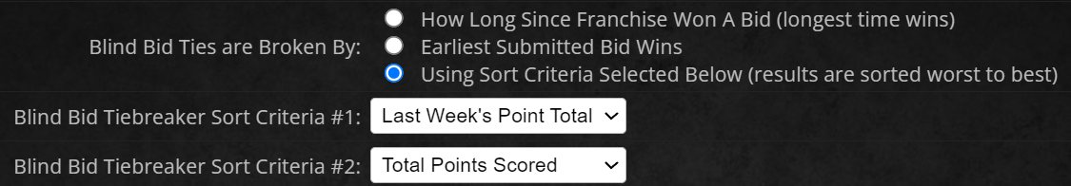
- Scoring outlined in MFL (rather balanced)
  - “Snack Time” owners - scoring is nearly identical. Very few differences (QB TDs 4 pts, not 6).
- “Guillotine” team scores are rolling two-week scores, i.e.
  - Week 3 guillotine score = Week 2 score + Week 3 score
  - Week 4 guillotine = Week 3 score + Week 4, etc.
- Starting Week 2, the lowest scoring 2 teams are eliminated (based on 2-week Guillotine score)
  - On Week 2, the two lowest Week 1 plus Week 2 team scores are eliminated
- Number of teams eliminated decrease through season
- Week 17 final week - 4 teams left. Top 3 scores earn 1st, 2nd, 3rd place prizes
- Prizes
  - 2025 Weekly Results (last year)
  - $50 x 24 teams = $1200 - $85 MFL fee = $1115 Prize Pool
    - Cash Weekly Prizes (starting Weeks 5-16) for top one-week, individual week’s score (e.g. Week 5 only, not Weeks 4+5) - $380 total
    - 1st place - $450
    - 2nd place - $200
    - 3rd place - $85
  - The $85 MFL fee is refunded back to the Commish

Scoring
The MFL scoring will be (should be) as follows (calculated to 2 decimal places):
QB, RB, WR, TE
Number of Passing TDs | 4 points each
Passing Yards | .03 point for every 1
Pass Interceptions Thrown | -2 point each
Passing 2 Point Conversions | 1 points each
Number of Rushing TDs | 6 points each
Rushing Yards | 0.1 point for every 1
Rushing Attempts | 0.25 point for every 1
Rushing 2 Point Conversions | 2 points each
Number of Receiving TDs | 6 points each
Receiving 2 Point Conversions | 2 points each
Fumbles Lost (to Opponent) | -2 points each
RB, QB
Receptions | 1 point for every 1
Receiving Yards | 0.1 point for every 1
WR
Receptions | 1.5 points for every 1
Receiving Yards | 0.1 point for every 1
Receiving Yards (Bonus) | 100+ | 3 points
TE
Receptions | 2 points each
Receiving Yards | 1 to 20 | 0.4 point for every 1
 | 21+ | 0.1 point for every 1

Draft Grid
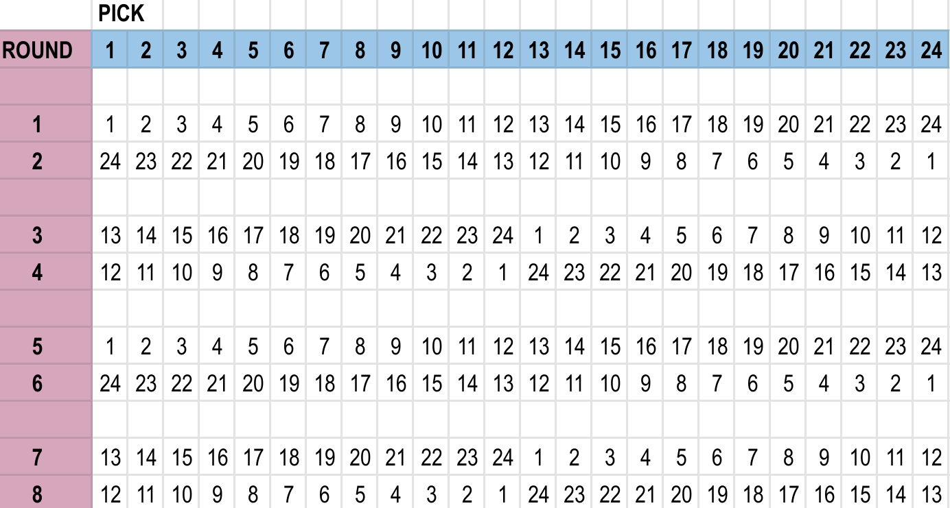

Weekly Schedule - Roster, Prize, Cuts
 |  |  |  | After Week's End
Week | Teams Alive Start | Roster Size | Starters / Bench | Top 1-Week Score Prize | Roster Changes | # of Teams Cut | Teams Left
1 | 24 | 8 | 1 QB, 2 RB, 2 WR, 1 TE, 2 FLX, 0 Bench | $10 FAAB | +1 bench | 0 | 24
2 | 24 | 9 | 1 QB, 2 RB, 2 WR, 1 TE, 2 FLX, 1 Bench | $10 FAAB | None | 2 | 22
3 | 22 | 9 | 1 QB, 2 RB, 2 WR, 1 TE, 2 FLX, 1 Bench | $10 FAAB | +1 bench | 2 | 20
4 | 20 | 10 | 1 QB, 2 RB, 2 WR, 1 TE, 2 FLX, 2 Bench | $10 FAAB | None | 2 | 18
5 | 18 | 10 | 1 QB, 2 RB, 2 WR, 1 TE, 2 FLX, 2 Bench | $10 | +1 FLX | 2 | 16
6 | 16 | 11 | 1 QB, 2 RB, 2 WR, 1 TE, 3 FLX, 2 Bench | $10 | None | 2 | 14
7 | 14 | 11 | 1 QB, 2 RB, 2 WR, 1 TE, 3 FLX, 2 Bench | $10 | +1 WR | 1 | 13
8 | 13 | 12 | 1 QB, 2 RB, 3 WR, 1 TE, 3 FLX, 2 Bench | $10 | None | 1 | 12
9 | 12 | 12 | 1 QB, 2 RB, 3 WR, 1 TE, 3 FLX, 2 Bench | $20 | + QB | 1 | 11
10 | 11 | 13 | 2 QB, 2 RB, 3 WR, 1 TE, 3 FLX, 2 Bench | $20 | None | 1 | 10
11 | 10 | 13 | 2 QB, 2 RB, 3 WR, 1 TE, 3 FLX, 2 Bench | $20 | + RB | 1 | 9
12 | 9 | 14 | 2 QB, 3 RB, 3 WR, 1 TE, 3 FLX, 2 Bench | $20 | None | 1 | 8
13 | 8 | 14 | 2 QB, 3 RB, 3 WR, 1 TE, 3 FLX, 2 Bench | $40 | + TE | 1 | 7
14 | 7 | 15 | 2 QB, 3 RB, 3 WR, 2 TE, 3 FLX, 2 Bench | $40 | None | 1 | 6
15 | 6 | 15 | 2 QB, 3 RB, 3 WR, 2 TE, 3 FLX, 2 Bench | $40 | + FLX | 1 | 5
16 | 5 | 16 | 2 QB, 3 RB, 3 WR, 2 TE, 4 FLX, 2 Bench | $40 | None | 1 | 4
17 | 4 | 16 | 2 QB, 3 RB, 3 WR, 2 TE, 4 FLX, 2 Bench |  |  | 3rd place - $60
 |  |  |  |  |  | 2nd place - $120
 |  |  |  |  |  | 1st place - $430

Weekly Scores Example
Single Week Scores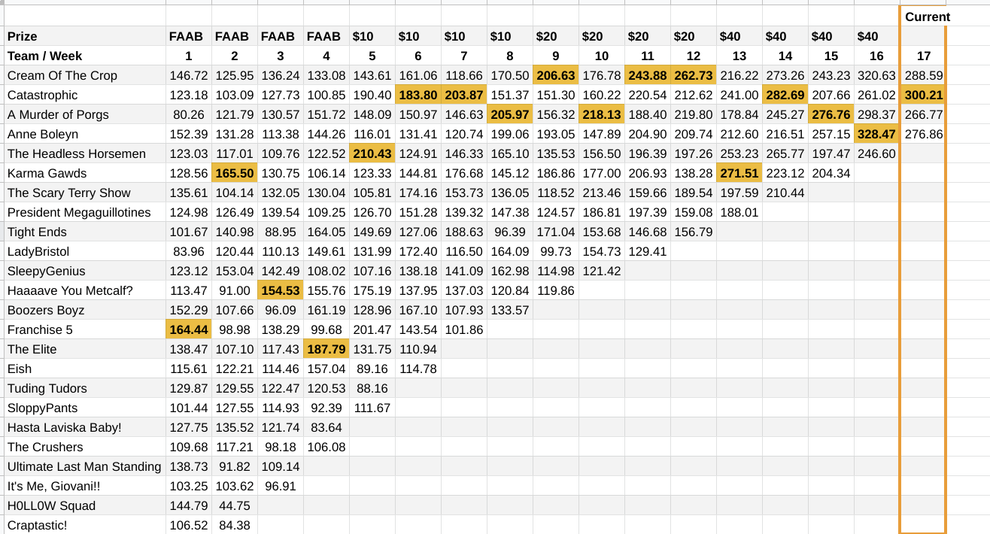
Combined Two-Week Scores